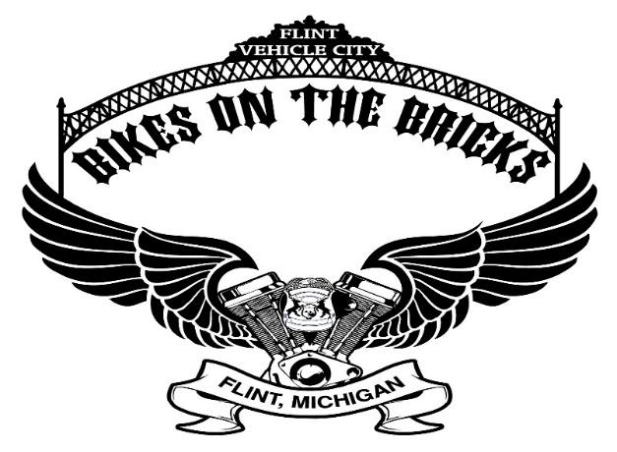

16th Anniversary Bikes on the Bricks
Bikes on the Bricks committee, a 501c3 organization, has organized the Bikes on the Bricks event on famous Saginaw Street in downtown Flint, Michigan for 16 years. Hundreds of thousands of participants and spectators have allowed this event is to raise funds for charitable organizations selected by the committee annually.
Proceeds from sponsorship and other charitable donations are eligible as a tax deduction in accordance with IRS laws.

Sponsorship/Supporter package opportunities
Our committee is committed to working with your organization to tailor Packages to fit your needs and accomplish our charitable goals.
Sponsorship deadline to appear on the event T-shirt is May 1st

Sponsorship Opportunities

Title Sponsor--$25,000 - Exclusive
- Exclusive exhibit space at the event
- Company logo on the very top back of the event T-shirts in large print
- Company logo on the front of the event flyer
- Logo on event T-Shirt sleeves
- Exclusivity within industry (event will not allow any other sponsors within Title Sponsor’s industry)
- Prominent individual banner (provided by organizer) on the stage in premium spot
- Announcements of company name by DJ during event
- May have T-shirts for their employees and staff using Bikes on the Bricks with their own logos (provided by sponsor)
- 10 individual mentions on social media
- Use of event stage for up to four ½ hour ‘events’
- Discount on registrations into the police escorted ride or merchandise for sponsor’s stakeholders
- Company logo on the official event Web site, with link
- 10 official event T-shirts

Presenting Sponsor--$15,000 (2)
- Premier exhibit space at the event
- Company logo on back of the event T-shirts in large print
- Company logo on the front of the event flyer
- Exclusivity within industry (event will not allow any other sponsors within Presenting Sponsor’s industry)
- Extra-large individual banner (provided by organizer) on the stage in premium spot
- Announcements of company name by DJ during event
- May have T-shirts for their employees and staff using Bikes on the Bricks with their own logos (provided by sponsor)
- 7 individual mentions on social media
- Use of event stage for up to three ½ hour ‘events’
- Discount on registrations into the police escorted ride or merchandise for sponsor’s stakeholders
- Company logo on the official event Web site, with link
- 8 official event T-shirts

Platinum Sponsor--$8,000
- Premium exhibit space at the event
- Company logo on the back of the event T-shirts in large print
- Exclusivity within industry (event will not allow any other sponsors within Platinum Sponsor’s industry)
- Large banner (provided by organizer) on the stage in premium spot
- Announcements of company name by DJ at event
- May have T-shirts for their employees and staff using Bikes on the Bricks with their own logos (provided by sponsor)
- 5 individual mentions on social media
- Use of event stage for up to two ½ hour ‘events’
- Company logo on the official event Web site, with link
- 6 official event T-shirts
- Additional Specialty Sponsor promotional opportunities available

Gold Sponsor--$4,000
- Premium exhibit space at the event
- Company logo on the back of the event T-shirts in large print
- Listed on large banner with Silver & Bronze Sponsor (provided by sponsor organizer) on the stage, in font size relative to sponsorship level
- Announcements of company name by DJ at event
- 5 individual mentions on social media
- Use of stage for one ½ hour ‘event’
- Company logo on the official event Web site, with link
- 4 official event T-shirts
- Additional Specialty Sponsor promotional opportunities available

Silver Sponsor--$2,000
- Exhibit space at the event
- Company logo on the back of the event T-shirts in medium print
- Listed on large banner with Gold & Bronze Sponsors (provided by organizer) on the stage, in font size relative to sponsorship level
- Company logo on the official event Web site, with link
- 4 official event T-shirts

Bronze Sponsor--$1,000
- Exhibit space at the event
- Company name on the back of the event T-shirts in small print
- Listed on large banner with Gold, Silver and other Bronze Sponsors (provided by organizer) on the stage, in font size relative to sponsorship level
- Company name on the official event Web site, with link
- 2 official event T-shirts

Friend of Bikes Supporters--$500
- Exhibit space at the event
- Company name on the back of the event T-shirts in small print
- Company name on the official event Web site, with link
- 2 official event T-shirts

Specialty Sponsors - $2,500

1) Stage Sponsor includes large Company Banner on S. Saginaw Street stage - $2,500
- Company logo on the back of the event T-shirts in medium print
- Company logo on the official event Web site, with link
- 4 official event T-shirts

2) Beer Tent Sponsor Includes multiple banners in Beer Tent - $2,500
- Company logo on the back of the event T-shirts in medium print
- Company logo on the official event Web site, with link
- 4 official event T-shirts

_____________________________________________________________________

Supporter Opportunities

Gift-in-Kind Contributors
- Will be listed on banner on the stage. Font size will coordinate with level of gift.
- Company logo on the official event Web site, with link
- Official event T-shirts

Note: Gift-in-Kind contribution value will be determined by the 501c3 estimated taxable value. Contributors may only qualify for a Silver Sponsorship or lower.
_____________________________________________________________________

Vendor Opportunities

Tent Street Vendors
2 days of tent in Premier area use for selling/promoting company - $250
2 days of tent in Ancillary area use for selling/promoting company - $100

Stage Vendors
Half Hour exclusive use of the stage for promotional opportunity - $250

Interested parties in Vendor opportunities should contact
Sara Besson at (810) 691-1903 or by email at sbesson@cityofflint.com

_____________________________________________________________________

Important Package Information

- Sponsorship deadline to appear on the event T-shirt is May 1st

- For Sponsorship/Supporter opportunities please contact

  - Bill Bailey: Bbailey@classicfox.com – (810) 347-8309
  - Chris Everson: flintownchris@gmail.com – (810) 908-7717

- Bikes on the Bricks organization is a listed 501c3 charity. All sponsors, supporters and Gift-in-kind contributors may request a Donor Benefit receipt for tax purposes.

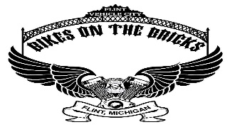
Sponsorship Commitment Form

Business Name: ___________________________________________________________
Contact Name: ____________________________________________________________
Contact Phone Number: _____________________________________________________
Email: ___________________________________________________________________
Website: _________________________________________________________________
Yes, my organization would like the following sponsorship package:

[ ] Presenting ($15,000)
[ ] Platinum ($8,000)
[ ] Gold ($4,000)
[ ] Silver ($2,000)
[ ] Bronze ($1,000)
[ ] Friend of Bikes ($500)

**Please include T-shirt sizes for our ordering ahead of the event**
XS( ) S( ) M( ) L( ) XL( ) 2XL( ) 3XL( ) 4XL( )

Please include a copy of your logo if applicable and return this form to:
Bikes on the Bricks
615 S Saginaw St, Suite #1016
Flint, MI 48502

